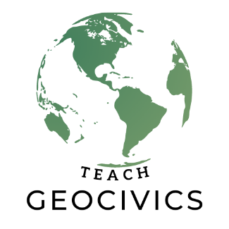
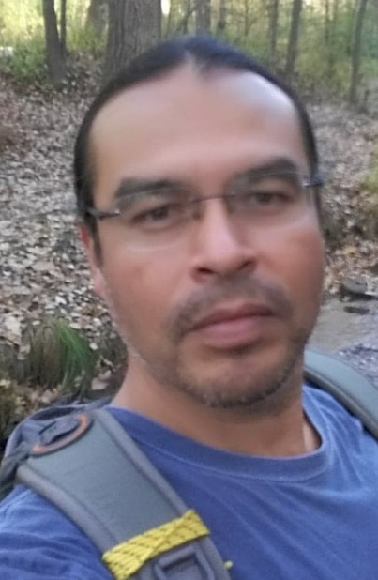
Wisconsin…
Greg Holder
Gregory Holder (Lakota & Wichita Nations) is a science and math teacher for grades 9 - 12 at the Oneida Nation High School, in Oneida, Wisconsin. He has a B.A. in Geography with a Minor in Ethnic Studies from the University of Colorado – Denver and a M.S. in Environmental Science and Policy from the University of Wisconsin – Green Bay. When he was pursuing his B.A. degree, Gregory served as a peer-advocate for Native, Hispanic, and other multi-cultural youth throughout the Denver area. His duties included tutoring high school and college freshman students in math and science subjects and advising students to attain their goals in higher education. In Wisconsin, while pursuing his M.S. degree, Gregory served as a substitute teacher and spec-ed/co-teacher for the Oneida Nation School System, and as a mentor and educator for the Green Bay Schools Title VI Indian Education Program. Presently, he serves the Oneida Nation community as a teacher, tutor, and support advocate for Wisconsin’s Native American/First Nations high school students that seek interest in math and science disciplines. Whether teaching in a classroom or outdoors, he delivers a holistic method that combines traditional Native environmental and societal principles with Westernize technological applications. In addition, Gregory is undergoing the first phenology trail for the Oneida Nation School System, which will be ceremoniously introduced in fall 2022.

