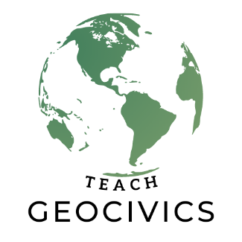
Virginia…
Frances Coffey
Frances Coffey has taught social studies in Fairfax County Public School in Northern Virginia for thirteen years. She earned her master’s degrees in Education and International Studies. She has taught world history, psychology, and geography. She enjoys travelling and reading, and she’s excited to be part of the GeoCivics Summer Academy.

