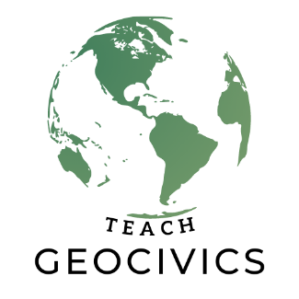
Arizona…
Elizabeth Fuiava
Greetings, my name is Elizabeth Fuiava and I have 24 years of experience in educating young minds through various capacities. I’ve taught for a combination of 19 years as a classroom teacher in American Samoa, Washington, and Arizona for levels K, 1st , 2nd, 3rd, 6th, 7th, and 8th grade. I earned my bachelor’s degree in elementary education through the University of Hawaii at Manoa in the fall of 2010 and a master’s in science for special education from Western Governors University in the fall of 2020. In 2017, I gained my Washington teacher residency certificate while working one year as a paraeducator, one year as a site director for the YMCA, and two years as a certified substitute teacher. I moved to Arizona in 2018 to help my husband start another church ministry branch for the First Samoan Full Gospel Pentecostal Church in which I’ve been actively involved in since 1996 as a leader for children’s choir and Bible ministry.

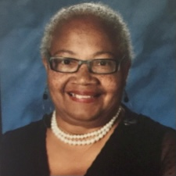
Nedre White
My name is Nedre White. I graduated from Arizona State University. I received my B.A. degree in Elementary Education and Master of Science in Educational leadership. I have taught English language development to students for many years. I am currently teaching students from grades K-12th. I wanted to take advantage of the GeoCivics program because learning and teaching is my passion. I am always looking for new ways to teach, so that I can enable each student to grow and have a successful experience learning English, and getting excited about learning. I am married and have four grown children. In my spare time I like to travel around the world.

Jeannine Kuropatkin
In a nutshell . . . I love teaching, am a life-long learner, and a self-proclaimed “geography fanatic.” My teaching career spans 34 years and has run the gamut from Pre-School to Elementary, Junior High, High School, and even Adult Education for Senior Citizens. The past six years, I have taught Pre-AP World History/Geography, Holocaust Studies, and AP Human Geography at Red Mountain HS in Mesa, Arizona. Beyond the classroom, I connect with students via campus clubs as the Model United Nations Sponsor, Native American Club Co-Sponsor and Cultural Ambassadors Club Co-Sponsor. Prior to teaching at RMHS, I taught junior high Social Studies (grades 7-8-9) for 23 years, including on-level and Honors classes.
As a professional, I am actively involved in Social Studies Education, taking on leadership roles as a Board Member of the Arizona Council for the Social Studies (ACSS) and as a Teacher Consultant for the Arizona Geographic Alliance (AzGA), as well as planning and presenting at workshops/conferences sponsored by both organizations. I am an avid curriculum writer with published Geography and History lessons on websites such as PBS Learning Media, Arizona Geographic Alliance, University of Arizona’s Center for Middle Eastern Studies, Fred T Korematsu Institute, and the educator journal, “The Geography Teacher.”
My undeniable passion is to convey to students the importance of examining US and world history, global issues, world cultures, and current events with a critical eye and an open mind. I have studied and traveled extensively in Japan, Mexico, South Korea, Sri Lanka, Morocco, Saudi Arabia, Singapore, Bahrain, UAE, Qatar, and Indonesia enabling me to share authentic cultural experiences and history in the classroom. I am dedicated to helping students attain the critical 21st century skills and knowledge they will need to be responsible stewards of both our nation and planet.
As an individual who has chosen to be a teacher, I am fulfilled with a purpose and mission that will far outlast my life on this planet. I am inspired by the words of Nelson Mandela, “Education is the most powerful weapon which you can use to change the world.”

