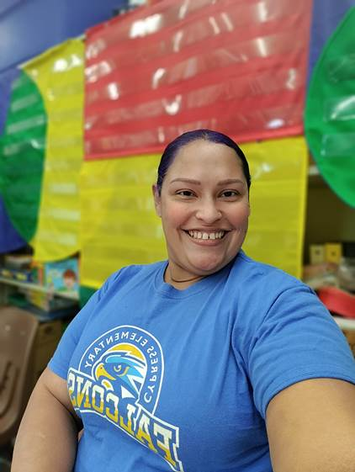
Florida…
Krizia Columna
I have been a dedicated, resourceful, and goal-driven professional educator with a solid commitment to the social and academic growth and development of every child. I have been an educator for the past 10 years in the state of Florida. I graduated with my bachelor’s degree in Pre-K/Primary Education from the Universidad del Este from Ana G. Mendez University System and have a graduate degree from Nova Southeastern University in Reading Education.

I am an elementary teacher that has instructed from Kinder through fifth grade, at the moment I am teaching multi grades K-3 in varying exceptionalities. I provide support facilitation to students who currently have an IEP through the district. I work at a Title I school. I am certified all the way through high school in ESOL, Reading, ESE. I currently hold a Gifted Endorsement and am working towards my Autism Endorsement. I am about to graduate this summer with an AA in Business Management with a Certificate in Cybersecurity. I was born in New York, raised in the Dominican Republic for a bit and came to live in Florida. I am fluent in both English and Spanish.

