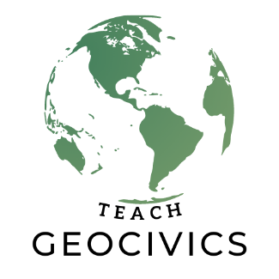
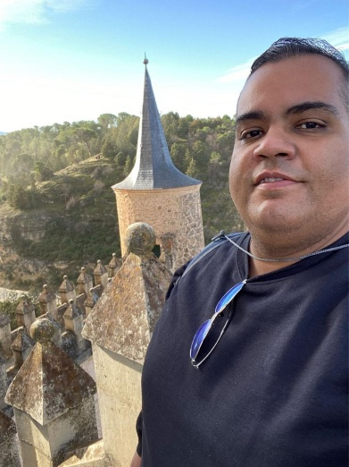
Puerto Rico…
Pedro DeJesus
He is an educator with 15 years of experience. He has worked in various instructional contexts in New York City and Puerto Rico. Pedro is a doctoral candidate at the University of Puerto Rico. His research focuses on the impact of educational legislation on the development of the Social Studies curriculum of the island. He is constantly looking for opportunities leading to learning and professional growth.

